User guide for Sound Blaster Application

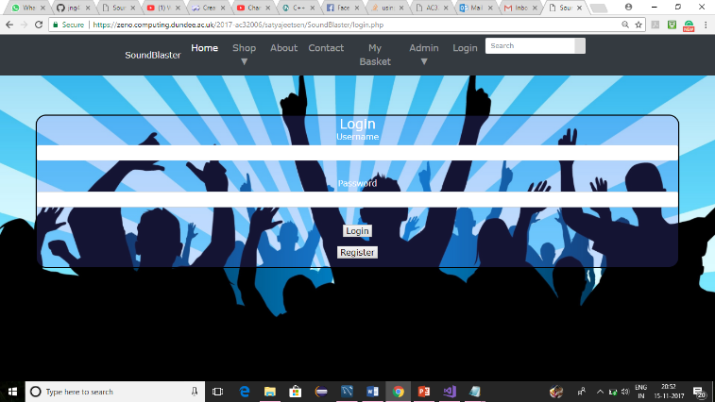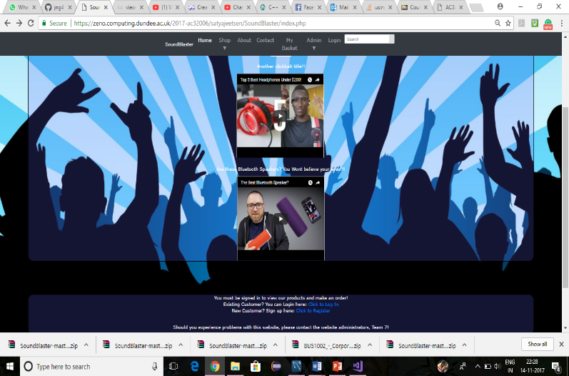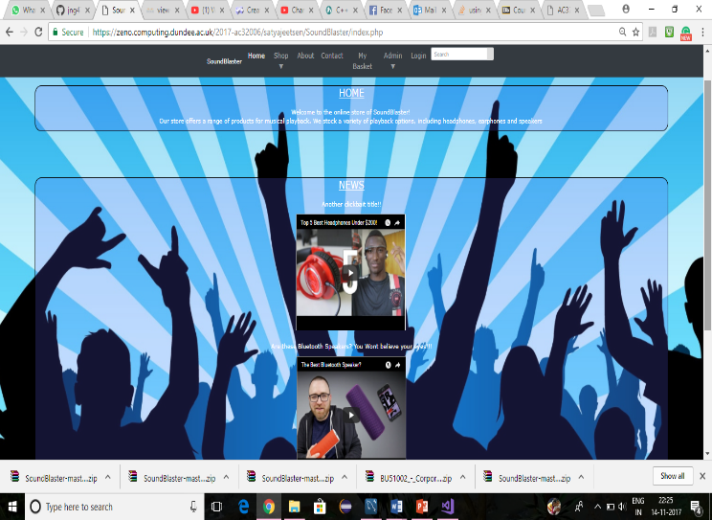

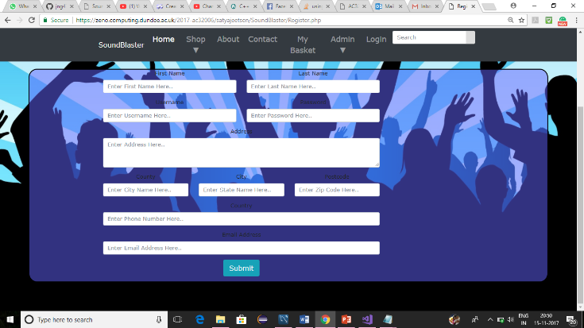Login, Home screen and Registration page

Login credentials username:-satya password:-satya for customer.

Web address:

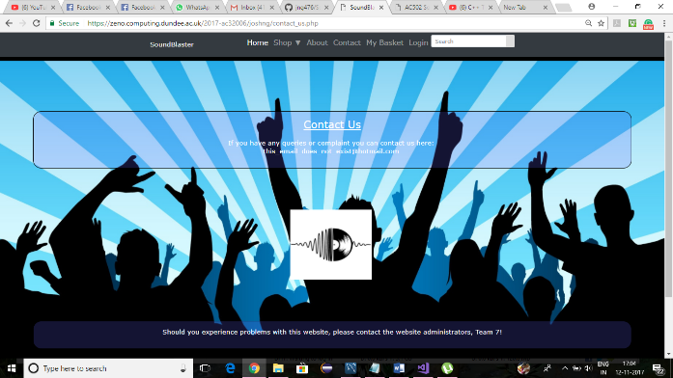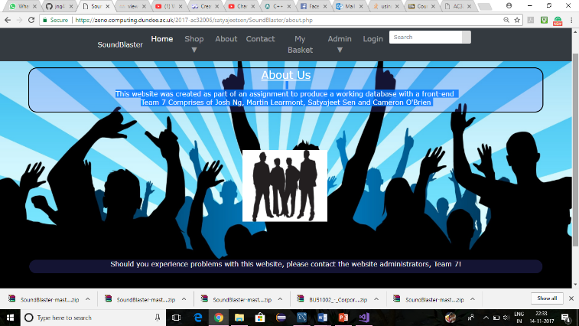When customer logins, he/she can see the home page containing information about the website. The new customer can also register for the site.

About us and Contact us page

About us and Contact us page

Customer navigates by clicking the about section leads to ‘About us’ page. Also customer navigates by clicking contact section loads the ‘Contact us’ page.

Shop dropdown

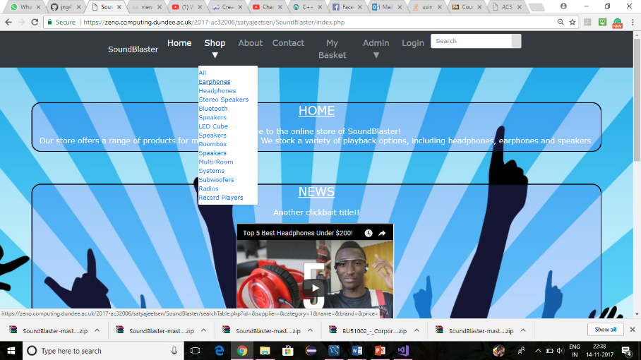

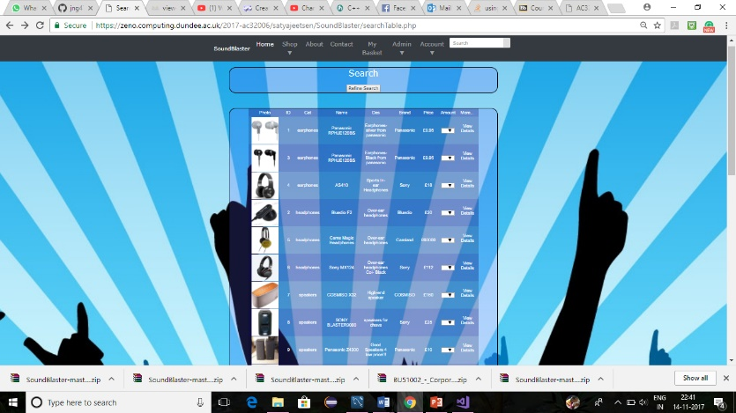

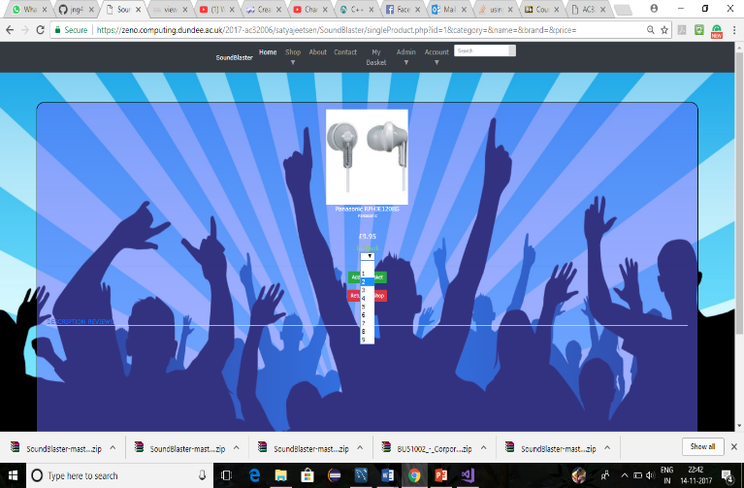

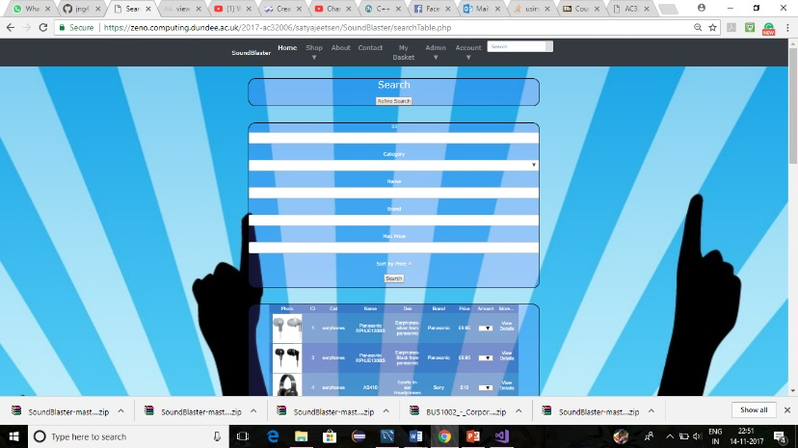

Shop/Earphones page

When customer clicks on shop dropdown at menu bar, he/she can see range of items list for sale (for example earphones, headphones, stereo speakers, Bluetooth speakers etc.). On clicking the earphones link a new search page appears giving description about all the earphones available for sale. On clicking all link from shop dropdown gives all the list of products available for sale. The user(customer) can also search for list of products by typing in ID, Category, Name, brand and maximum price. For each item the user can view details of product.

Queries: -

For search by ID “SELECT product.ID,product.Name,product.Description,product.Brand,product.OnlinePrice,category.name as Cat from product INNER JOIN category on category.id=product.categoryID where product.ID is like %1% ”;

For search by Name “SELECT product.ID,product.Name,product.Description,product.Brand,product.OnlinePrice,category.name as Cat from product INNER JOIN category on category.id=product.categoryID where product.Name is like %Panasonic RPHJE120BS% ”;

For search by Brand “SELECT product.ID,product.Name,product.Description,product.Brand,product.OnlinePrice,category.name as Cat from product INNER JOIN category on category.id=product.categoryID where product.Brand is like %Panasonic% “;

For search by Price “SELECT product.ID,product.Name,product.Description,product.Brand,product.OnlinePrice,category.name as Cat from product INNER JOIN category on category.id=product.categoryID where product.OnlinePrice is like %9.95%“;

For search by sortPrice “SELECT product.ID,product.Name,product.Description,product.Brand,product.OnlinePrice,category.name as Cat from product INNER JOIN category on category.id=product.categoryID where ORDER BY product.OnlinePrice";

For search by all inputs “SELECT product.ID,product.Name,product.Description,product.Brand,product.OnlinePrice,category.name as Cat from product INNER JOIN category on category.id=product.categoryID where

product.Name is %like% AND product.Brand is %like% AND product.OnlinePrice >=is %like%”

* Product.Name=AS410
* Product.Brand=Sony
* Product.OnlinePrice>=10

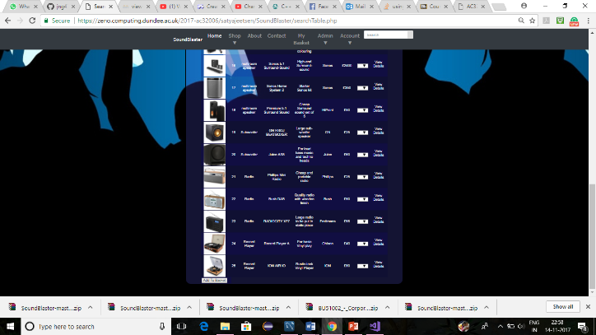

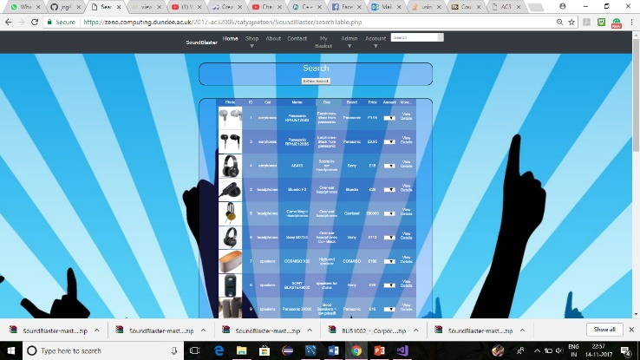

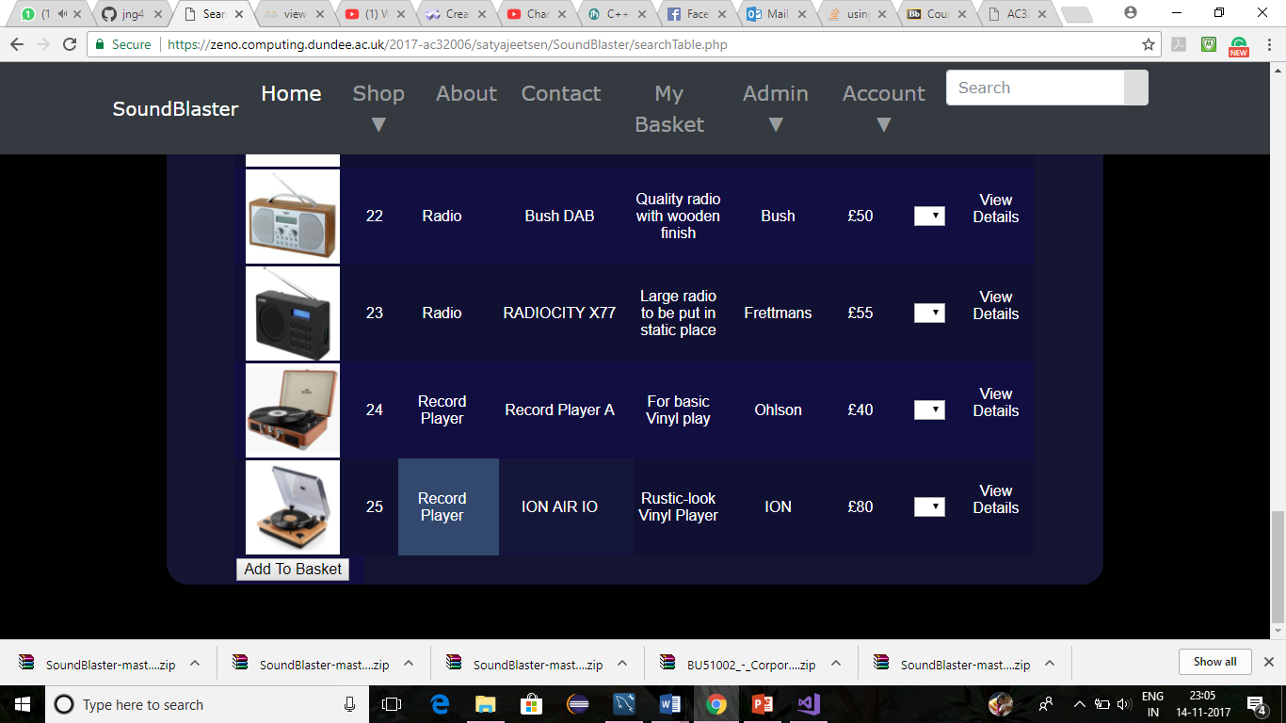

Shop/All page

In the list of products available, a customer can choose the amount or quantity of products he/she needs and then add to basket.

For search by All “SELECT product.ID,product.Name,product.Description,product.Brand,product.OnlinePrice,category.name as Cat from product INNER JOIN category on category.id=product.categoryID”;

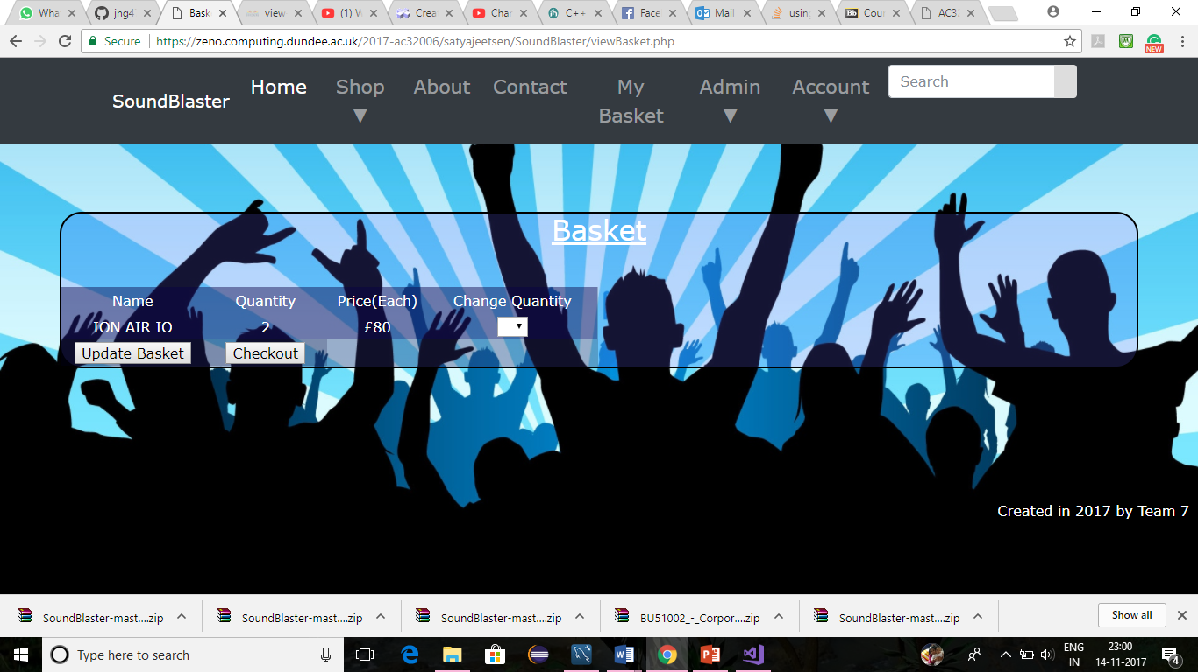

Add to Basket Page

Add to Basket

Adds the list of products and quantity to the basket. The customer can checkout the list of products he/she wants or can update the basket as well.

Query:- SELECT Name, OnlinePrice FROM product WHERE ID = ".$_SESSION['Basket']->ID[$i];

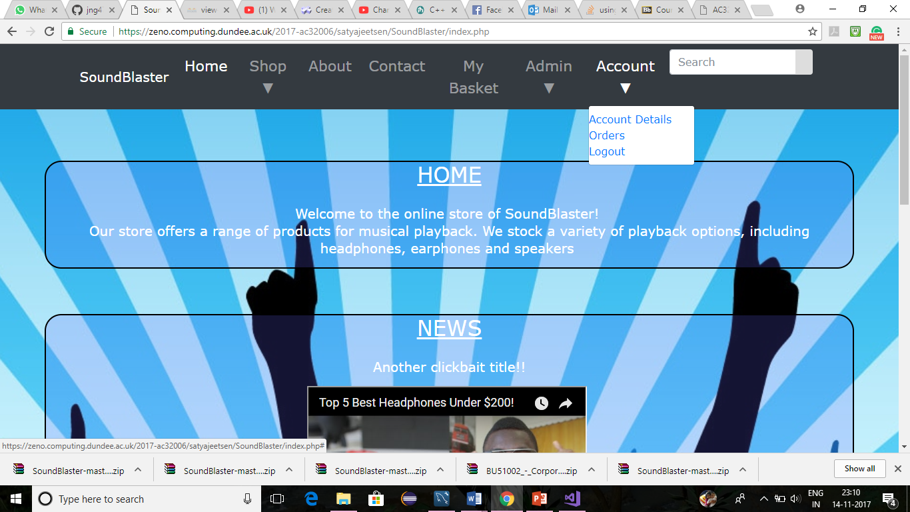

Account dropdown

On clicking the account dropdown in menu bar the customer can see account details, orders he created in the past, settings and logout of the website.

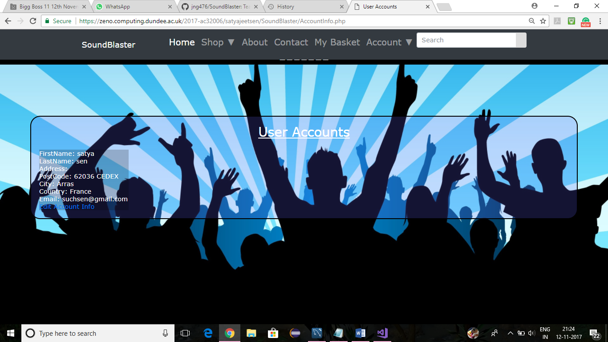

Account/Account Details

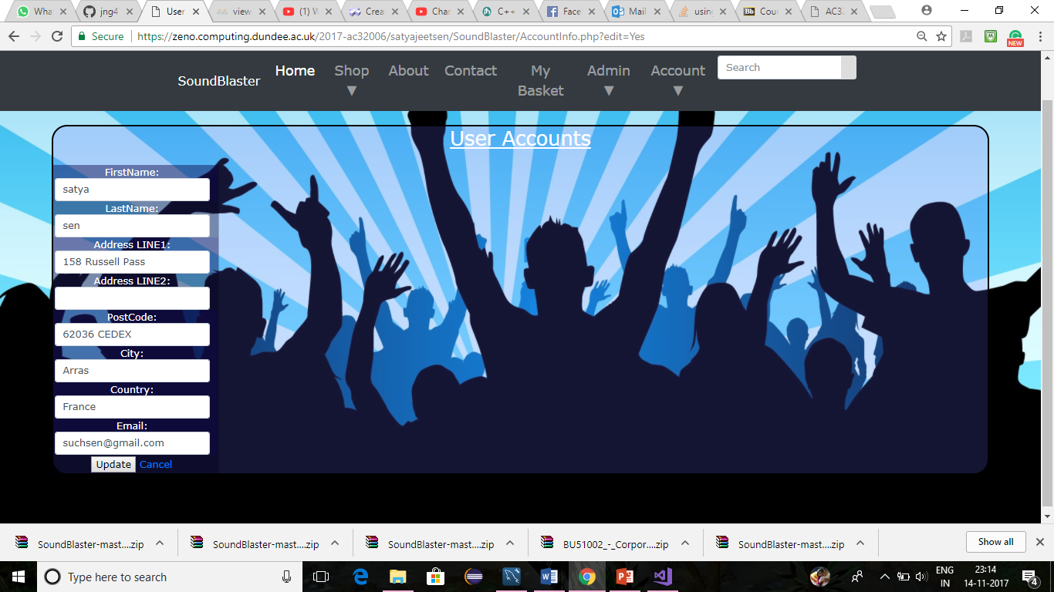

Account/Account Details/editAccountInfo

The user can see account details consisting of first name, last name, address and email and can update the information by clicking edit account info.

Queries:-

a)Account details:-“SELECT customer.*,address.LINE1,address.LINE2,address.PostCode,address.Country,address.City, GROUP_CONCAT(address.LINE1,address.LINE2) AS Address FROM customer JOIN useraccount on useraccount.customerid=customer.id INNER JOIN address on address.id=customer.AddressID where username ='".$_SESSION['username']"'

b)edit Account details

|  |  |
| --- | --- |
| Query:- UPDATE customer JOIN Address.id=customer.AddressID JOIN useraccount ON useraccount.ID=customer.ID SET FirstName='".$_POST['FirstName']."', LastName = '".$_POST['LastName']."', Email = '".$_POST['Email']."',  LINE1 = '".$_POST['Line1']."', LINE2 = '".$_POST['Line2']."', PostCode = '".$_POST['PostCode']."', City = '".$_POST['City']."', Country = '".$_POST['Country']."'  WHERE useraccount.username = '".$_SESSION['username']."'"; |  |
|  |  |
|  |  |

‘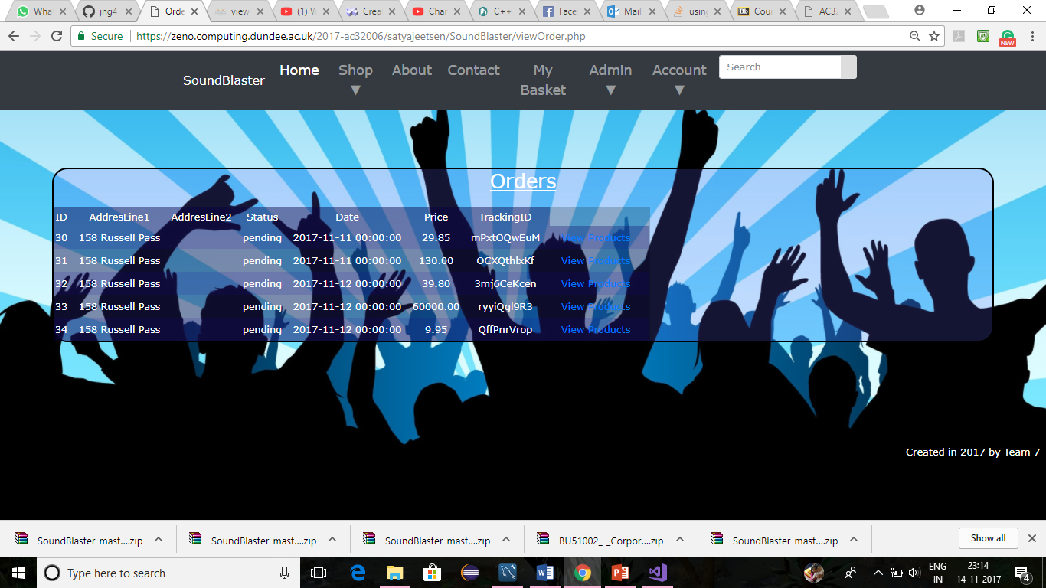

Account/Orders

Query for orders:-

"SELECT customer_order.ID, address.Line1, address.line2, customer_order.status, customer_order.date, ROUND(SUM(orderline.price), 2) AS price, customer_order.trackingID FROM customer_order

JOIN orderline ON customer_order.ID = orderline.OrderID

JOIN address ON customer_order.AddressID = address.id

where customerid = (SELECT useraccount.customerid from useraccount where username = '".$_SESSION['username']."')

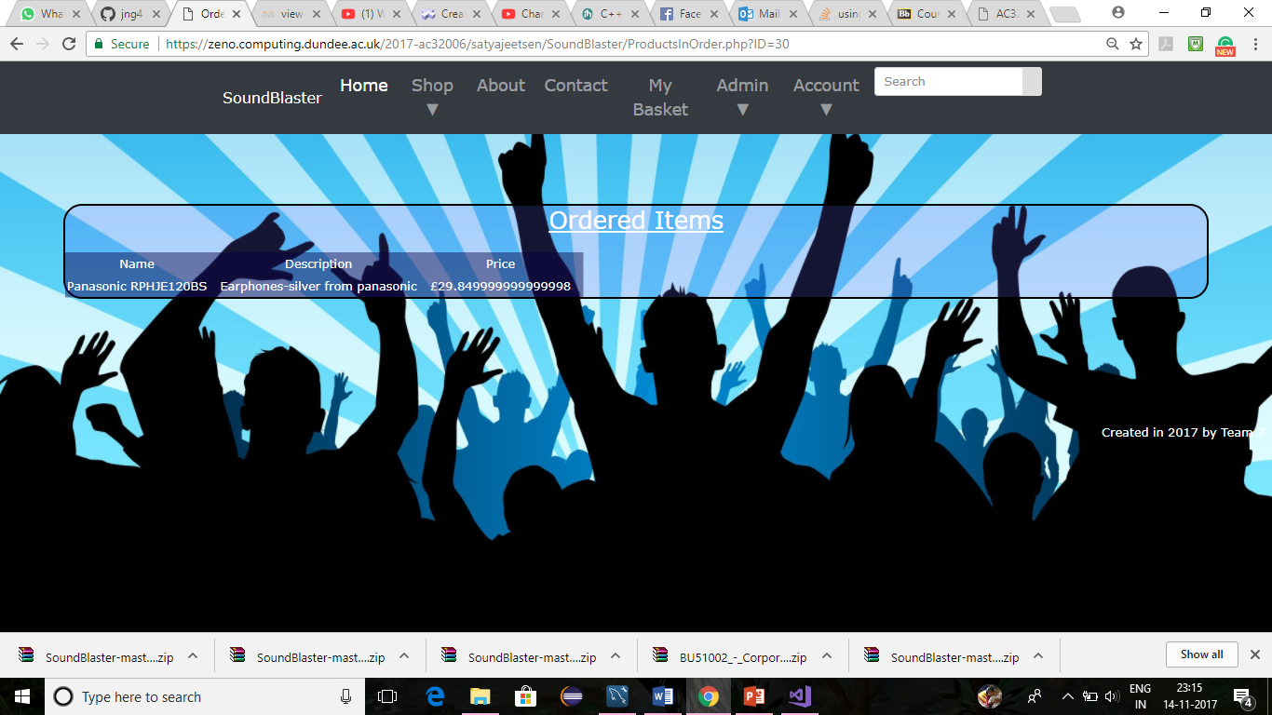

Account/Orders/view products

The customer can view any past orders against his/her name. It shows id, address, tracking order number, status of order, date of order and price of order. On clicking view products link, it shows the list of ordered items which includes Name, description and price.

Query for view products:-

"SELECT product.Name, product.description, (product.OnlinePrice*orderline.quantity) AS Price FROM orderline JOIN product ON product.ID = orderline.ProductID where orderline.OrderID = ".$_GET['ID'];

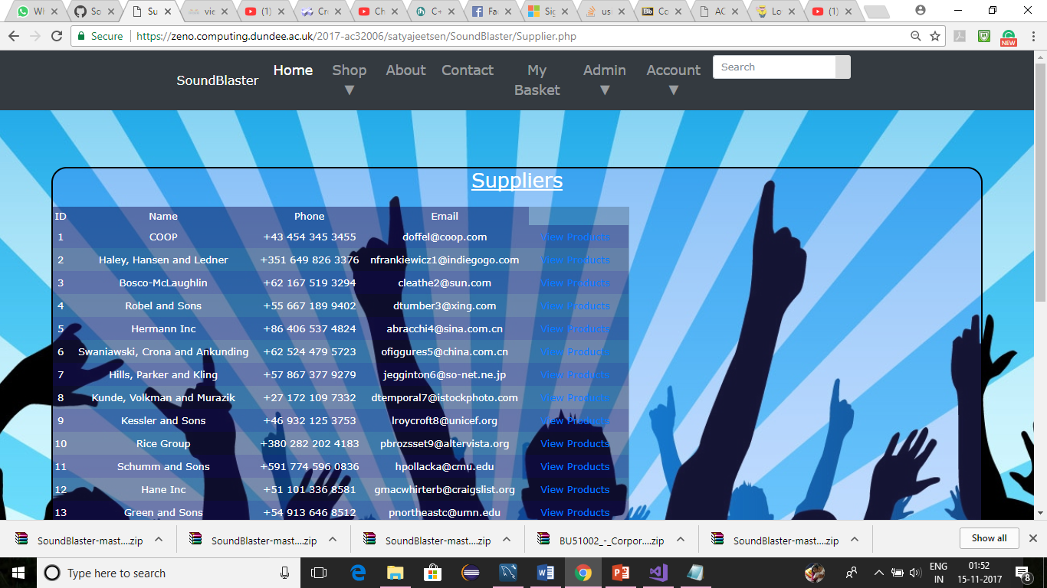

Admin/View Suppliers and their products

The user can view the id, supplier name, phone ,email address along with their products(view products link).

Query:- "SELECT * FROM Supplier"

View products:-The user can view name of product, description and supplier price.

Query:- "SELECT Name, Description, SupplierCost FROM Product WHERE SupplierID = ".$_GET['supplierID'];

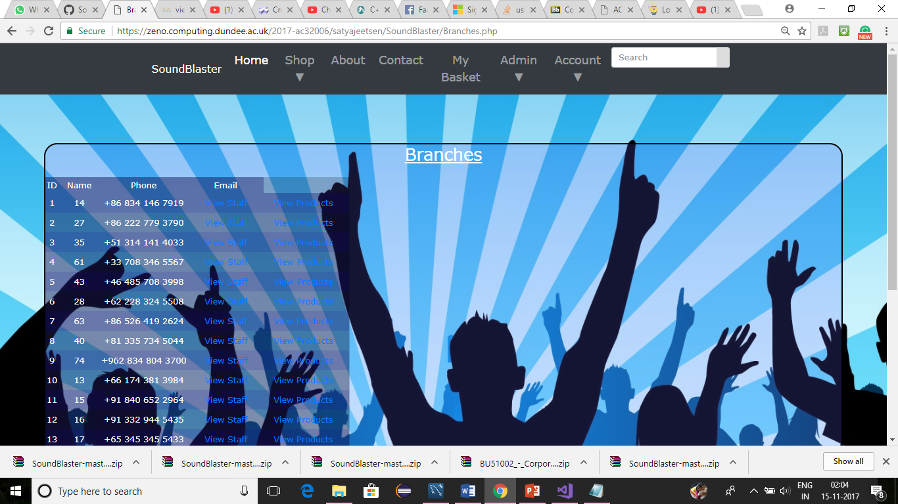

Admin/view branches

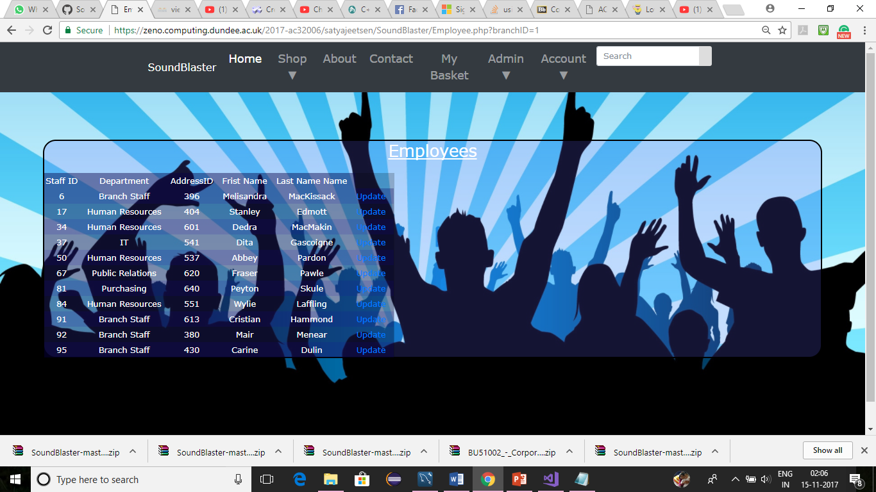

Admin/view branches/view staff

The user can view staff from admin dropdown to view branches and to view staff. Staff details such as staff id, department, address id, first name, last name are shown and which are editable.

Query:- "SELECT staff.*, Department.Name AS Dep FROM staff INNER JOIN Department ON staff.DepartmentID = Department.ID WHERE BranchID = ".$_GET['branchID'];

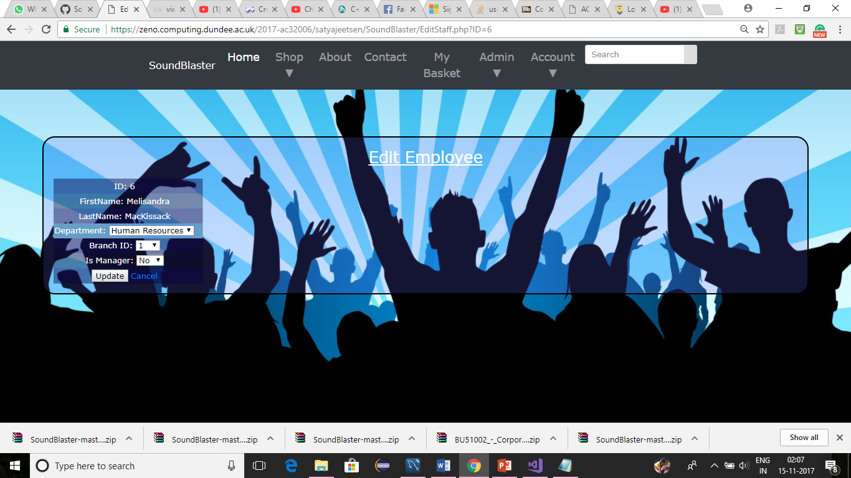

Admin/view branches/view staff/Edit staff

User can edit Department,branch id and isManager section.

Query:- UPDATE staff SET DepartmentID = ".$Department.", BranchID = ".$BranchID.", IsManager = ".$IsManager."WHERE ID = ".$ID;

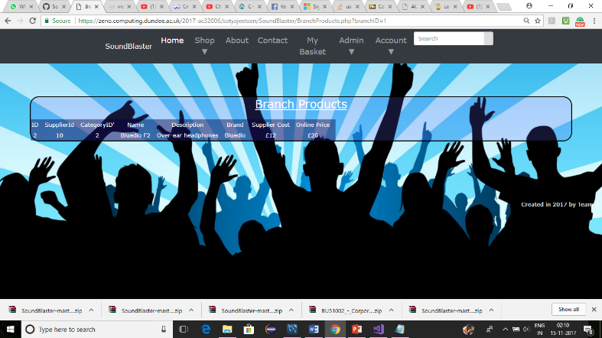

Admin/view branches/view products

The user can view products from branches.Details such as supplier-id,category-id,name,description,brand,supplier cost and online price is shown to supplier.

Query:- "SELECT * FROM product JOIN branchproduct ON product.ID = branchproduct.ProductID WHERE BranchID= ".$_GET['branchID'];

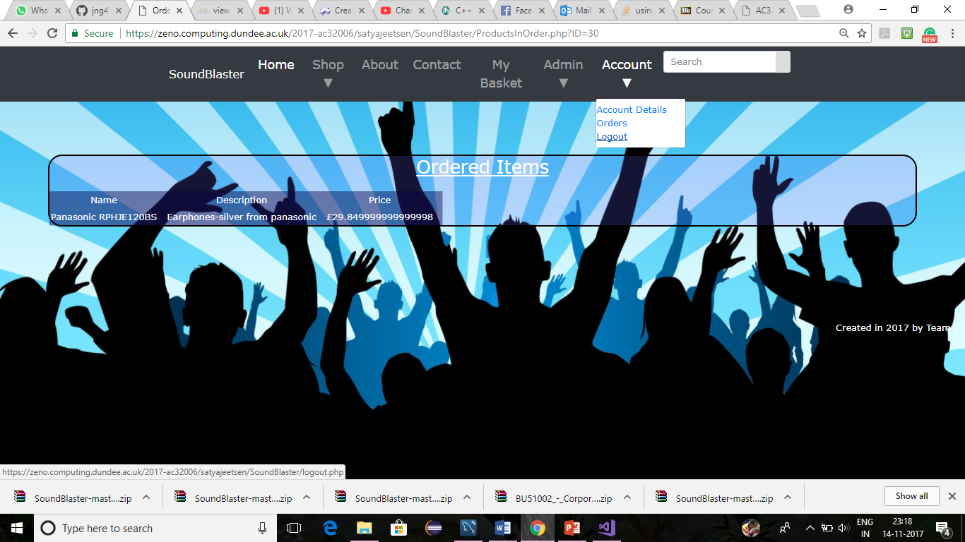

Account/logout

A customer can logout from the website by clicking on accounts on menubar and logout link.